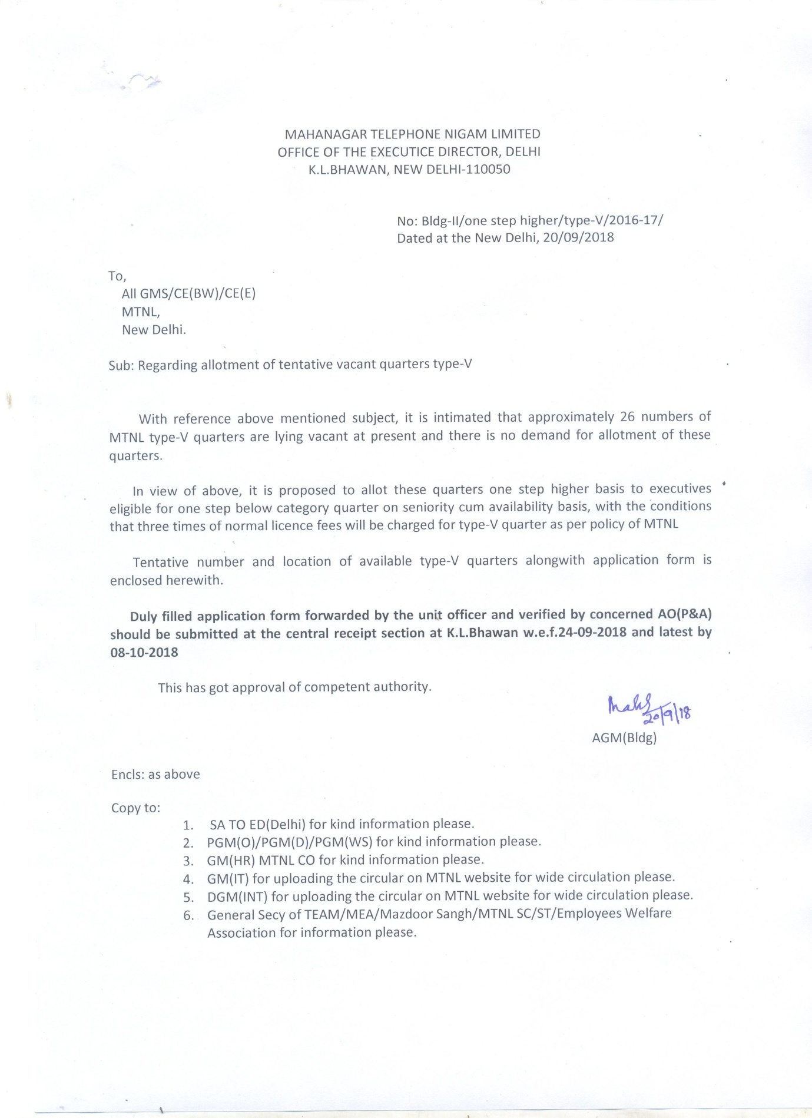

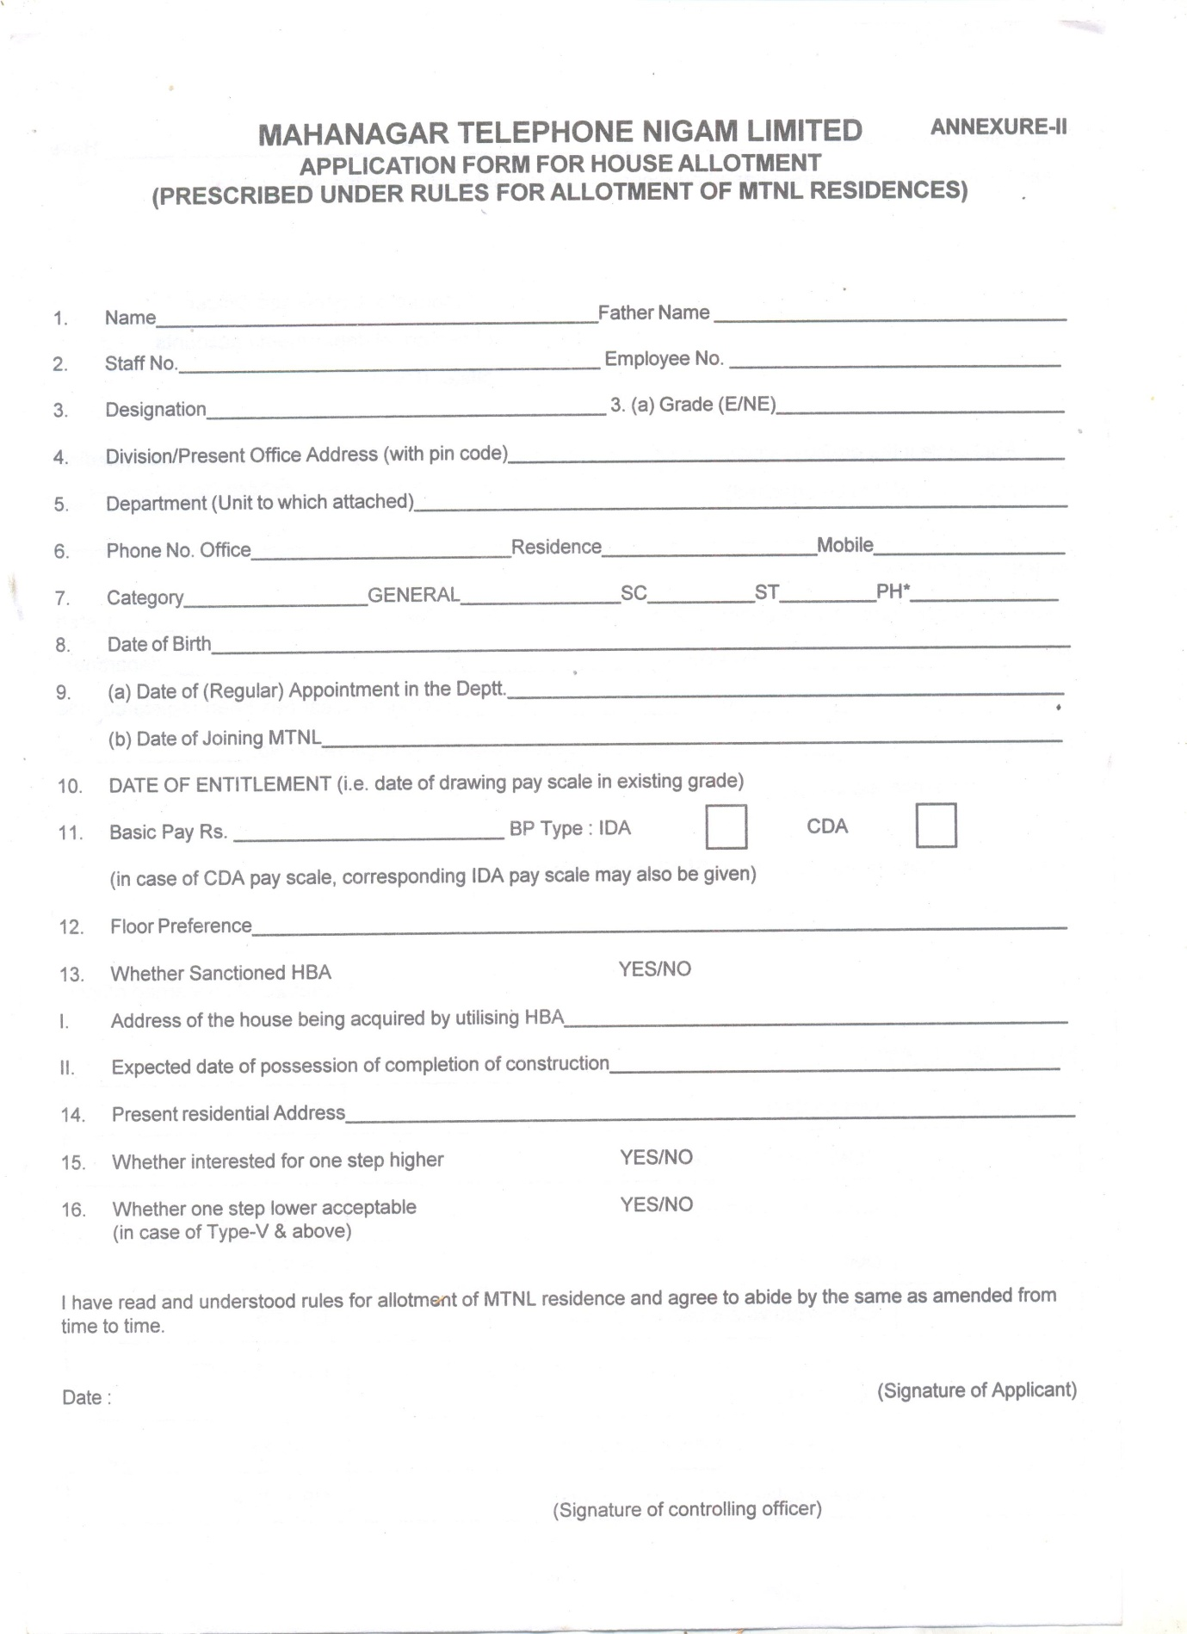

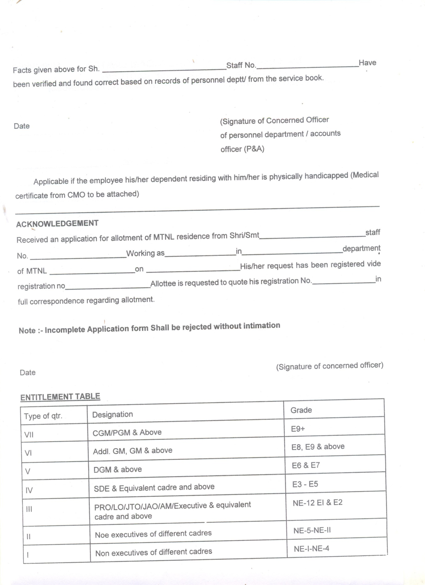

THE DETAILS OF TYPE WISE AND LOCATIONS WISE VACANT QUARTERS IS AS UNDER:
AS ON 20-09-2018:
S.NO | LOCALITY | NO
1 | ROHINI | 17
2 | PASCHIM VIHAR | 7
3 | ANDREW GANJ | 2
 | TOTAL | 26

